Task 1

Implement the sign up form below. Use Angular 9+ framework, or Javascript + HTML + CSS.

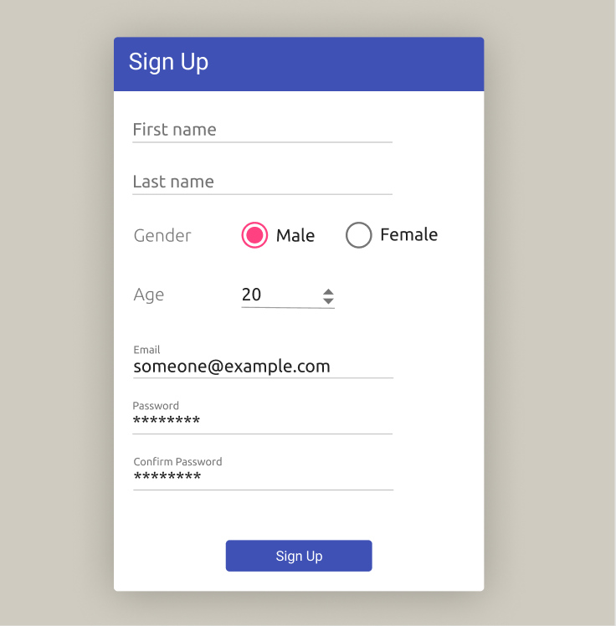

The form should have adaptive layout. Usage of CSS Flexbox is preferable. If width of dialog is less then 350, input fields should fill the entire width of dialog and be located under each other. Otherwise, layout should be adapted when width is enough for it:

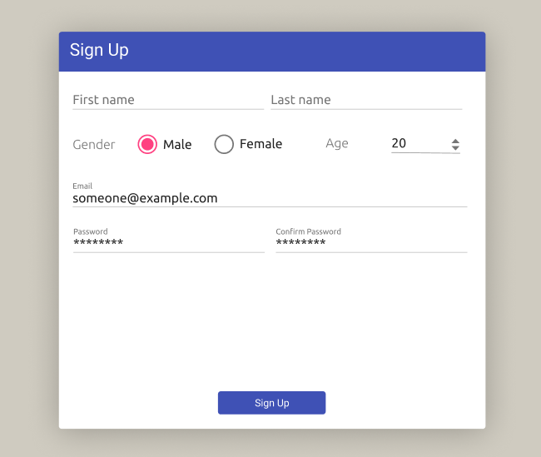

Requirements:

* All fields are mandatory. On ‘Sign up’ button click errors should be shown under each empty field.
* The ‘Age’ field should apply digit only inputs and its value should be limited in [10; 100], and can be changed via arrows with step = 1.
* The ‘Email’ field should be checked on validity via regular expression.
* ‘Password’ and ‘Confirm Password’ fields should display asterisks instead of characters.
* ‘Sign Up’ button should be disabled until mandatory fields are filled and valid.
* After clicking on ‘Sign up’ button message window should be shown with information taken from Sign Up form fields. The window should contain ‘Sign up again’ button. Clicking on it should close the message window and clear all filled field in the message form.

Implemented solution should contain:

* Production built (in case of Angular)
* Source code

It is allowed to use Stackblitz platform to share solution.

Task 2

Extend previous task.

* Create simple server. You can use Node.js JSON server.
* Store all created users data in JSON file.
* On ‘Sign up’ button click, message window will show information about just created user, and then list and information of already created users.
* There should be still ‘Sign up again’ button to create new user.

Implemented solution should contain:

* Production built (in case of Angular)
* Source code